# **Klipper Tricks**

## **Super Slicer controlled temperatures**

[gcode_macro PRINT_START]

# Use PRINT_START for the slicer starting script - please customise for your slicer of choice

default_parameter_BED_TEMP: 101

default_parameter_EXTRUDER_TEMP: 235

gcode:

M117 Heating...

M140 S{BED_TEMP} ; set bed final temp

M104 S{EXTRUDER_TEMP} ; set extruder final temp

M190 S{BED_TEMP} ; wait for bed final temp

M109 S{EXTRUDER_TEMP} ; wait for extruder final temp

M900

G21 ; set units to millimeters

G90 ; use absolute coordinates

M83 ; use relative distances for extrusion

G32 ; home all axes

G1 Z20 F3000 ; move nozzle away from bed

This is the screenshot from within SS that needs to be done and the printer.cfg PRINT_START macro(edited)

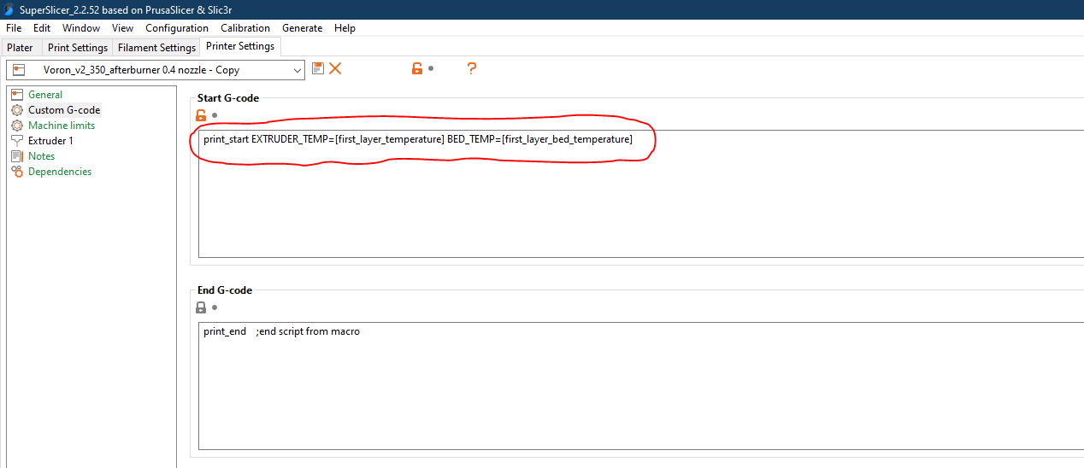

## **Heat Soak Trick**

#Pause/Resume Functionality

[pause_resume]

#Wait for chamber temp, kick off wait loop if not already at temp

[gcode_macro M191]

default_parameter_S: 0

variable_chambertargettemp: 0

gcode:

SET_GCODE_VARIABLE MACRO=M191 VARIABLE=chambertargettemp VALUE={S} ; set target temp for reference outside of the macro (for the loop)

{% if not printer["temperature_sensor chamber_temp"].temperature >= S|int %} ; ##IF CHAMBER TEMP IS NOT ALREADY REACHED##

{ action_respond_info("Chamber not at temp yet, pausing...") }

{% if not printer.pause_resume.is_paused %}

PAUSE ; pause if not already paused

{% endif %}

UPDATE_DELAYED_GCODE ID=M191-Wait DURATION=5 ; start wait loop

{% else %}

{ action_respond_info("Chamber at or above temp, continuing...") } ; ##IF CHAMBER TEMP IS ALREADY REACHED##

UPDATE_DELAYED_GCODE ID=M191-Wait DURATION=0 ; break wait loop if it happens to be running already (shouldn't be)

{% if printer.pause_resume.is_paused %}

RESUME ; resume if paused (shouldn't be)

{% endif %}

{% endif %}

#This part will loop until the desired chamber temp is reached, then resume the print

[delayed_gcode M191-Wait]

gcode:

{% if printer["temperature_sensor chamber_temp"].temperature >= printer["gcode_macro M191"].chambertargettemp|int %} ; ##IF CHAMBER TEMP IS REACHED##

{ action_respond_info("Chamber at or above temp, continuing...") }

{% if printer.pause_resume.is_paused %}

RESUME ; break loop, resume print

{% endif %}

{% else %} ; ##IF CHAMBER TEMP IS NOT YET REACHED##

{ action_respond_info("Chamber not at temp yet, waiting...") }

UPDATE_DELAYED_GCODE ID=M191-Wait DURATION=5 ; continue waiting loop

{% endif %}

So M191 S45 will wait for chamber temp to reach 45 degrees then resume print, for example. M191 S0 will break out of the wait loop and continue.

I am using a chamber thermistor but you should be able to sub in the hotend... just replace

printer["temperature_sensor chamber_temp"].temperature

with

printer.extruder.temperature

You can comment out the action_respond_info lines if you don't want it being so verbose in the terminal. **IMPORTANT CAVEAT: This does not like being run inside of other macros.** Klipper doesn't like pausing mid-macro. Put it as a separate line in your slicer start gcode, or put it as the very last line of a macro. I had to split my PRINT_START into 2 parts (see below).(edited)

## **Bed Mesh Setup**

You'll have a bad time with bed mesh if you're missing this setting:

##FOLLOW THE FORUMULA FOR relative_reference_index, for example:

##[(7x7)-1] / 2 = 24

probe_count: 7,7

relative_reference_index: 24

Here just use my config

[bed_mesh]

mesh_min: 30,50

mesh_max: 320,300

speed: 300

horizontal_move_z: 6

probe_count: 7,7

algorithm: bicubic

relative_reference_index: 24

#fade_start: 1

# Default is 1.0.

#fade_end: 10

# Default is 0.0, which disables fade.

#fade_target: 0

# The z position in which fade should converge.

move_check_distance: 3

# The distance (in mm) along a move to check for split_delta_z.

# This is also the minimum length that a move can be split. Default

# is 5.0.

split_delta_z: 0.0125

# The amount of Z difference (in mm) along a move that will

# trigger a split. Default is .025.

mesh_pps: 4,4

# A comma separated pair of integers (X,Y) defining the number of

# points per segment to interpolate in the mesh along each axis. A

# "segment" can be defined as the space between each probed

# point. The user may enter a single value which will be applied

# to both axes. Default is 2,2.

#bicubic_tension: 0.2

# When using the bicubic algorithm the tension parameter above

# may be applied to change the amount of slope interpolated.

# Larger numbers will increase the amount of slope, which

# results in more curvature in the mesh. Default is .2.

## **Yet Another Heat Sock Script**

If anyone is interested, this is my heat_soak script for frurunning before prints:

[gcode_macro heat_soak]

gcode:

{% if printer.toolhead.status == "Ready" %}

G28

G1 Z10

G1 X150 Y150 F6000

M140 S100

UPDATE_DELAYED_GCODE ID=heatsoakDelay DURATION=600

{% else %}

M117 "Load disabled while printing!"

{% endif %}

[delayed_gcode heatsoakDelay]

gcode:

M117

SET_PIN PIN=caselight VALUE=1

G4 P250

SET_PIN PIN=caselight VALUE=0

G4 P250

SET_PIN PIN=caselight VALUE=1

G4 P250

SET_PIN PIN=caselight VALUE=0

It centers the nozzle turns on the bed and then after 10 minutes flashed the lights

hey @Saiyanslayer you define defaults for parameters before the gcode section, with the prefix default_parameter_ such as:

[gcode_macro PARK_MACRO]

default_parameter_X: 20

default_parameter_Y: 330

default_parameter_Z: 100

gcode:

SAVE_GCODE_STATE NAME=PARK_MACRO_state

G91 ; relative positioning

G1 E-2 F1000 ; retract filament

G1 Z10 ; lift z slightly

G90 ; absolute positioning

G1 X{X} Y{Y} Z{Z} F3000 ; park the head

RESTORE_GCODE_STATE name=PARK_MACRO_state

[gcode_macro START_PRINT]

default_parameter_BED_TEMP: 100

default_parameter_EXTRUDER_TEMP: 245

gcode:

{% if printer.heater_bed.temperature <= (BED_TEMP|int - 20) %}

M190 S{BED_TEMP|int-20}

{%endif %}

M104 S{EXTRUDER_TEMP|int-40}

M190 S{BED_TEMP}

M109 S{EXTRUDER_TEMP|int-40}

G32

G1 Z5 F5000

M109 S{EXTRUDER_TEMP}

[12:03 PM]

and the start gcode in prusaslicer now looks like:

[12:04 PM]

START_PRINT BED_TEMP=[first_layer_bed_temperature] EXTRUDER_TEMP={first_layer_temperature[0]}

M109 S{first_layer_temperature[0]};

M190 S[first_layer_bed_temperature];

[12:04 PM]

the m109 & m190 shouldn't be needed, except if the slicer doesn't see them, it assumes it should add its own at the beginning. I haven't figured out a way around that yet